TrailQuest-Adventure and Trekking Website

1. Introduction
The TrailQuest Adventure and Trekking Website is a responsive website developed using HTML5 and CSS3. It provides information about trekking routes, camping trips, difficulty levels, trip schedules, equipment checklists, safety guidelines, and adventure packages.
The main objective of this website is to help adventure lovers explore trekking destinations, compare packages, prepare for trips, and send enquiries about their next adventure.
Website name: TrailQuest
Tagline: Explore • Trek • Belong
Technologies used:
- HTML5: Creates the structure and content of the website.
- CSS3: Provides styling, layouts, colors, hover effects, and responsive design.
- External images: Display mountain landscapes, trekking routes, and camping scenes.

2. Explanation of the Code
The code consists of two main parts: HTML and CSS.
A. HTML code explanation
HTML defines the structure and content of the website.
HTML tag | Explanation
<!DOCTYPE html> | Declares the document as HTML5.
<html lang="en"> | Defines the HTML document and its language.
<head> | Contains the page settings and title.
<meta> | Sets character encoding and viewport settings for responsive design.
<title> | Sets the browser tab title to TrailQuest.
<style> | Contains the CSS styling code.
<body> | Contains all visible website content.
<header> | Displays the logo, navigation links, and booking button.
<nav> | Provides links to different website sections.
<section> | Separates the website into organized content areas.
<div> | Groups related elements together.
<h1>, <h2>, <h3> | Display headings at different levels.
<p> | Displays descriptions and other text.
<a> | Creates clickable navigation links and buttons.
<span> | Highlights text, such as trekking difficulty labels and prices.
<ul> and <li> | Display the safety guidelines as a list.
<img> / CSS background images | Display trekking and camping images.
<form> | Creates the adventure enquiry form.
<input> | Accepts the visitor's name and email.
<select> and <option> | Allow visitors to select a trekking package.
<button> | Provides the enquiry submission control.
<footer> | Displays the website name, tagline, and copyright information.
B. CSS code explanation
CSS controls the appearance, alignment, and layout of the website.
- Universal selector (*): Removes default margins and padding and applies box-sizing: border-box.
- Body styling: Sets Arial as the font, a light background, dark text, and suitable line spacing.
- Header styling: Creates a dark blue navigation bar with a green-highlighted logo.
- Hero section: Uses a mountain background image with a dark gradient overlay to improve text visibility.
- CSS Grid: Arranges trekking cards, equipment items, difficulty levels, and package cards.
- Flexbox: Aligns navigation links, route details, and schedule information.
- Hover effects: Move trekking and package cards slightly upward when users hover over them.
- Pseudo-element (::after): Adds a dark gradient overlay to trekking card images.
- Border radius and shadows: Give cards and buttons a polished appearance.
- Media queries: Adjust the layout for tablets and mobile phones.
- Smooth scrolling: Allows users to move smoothly between sections when clicking navigation links.

3. Features of the Website
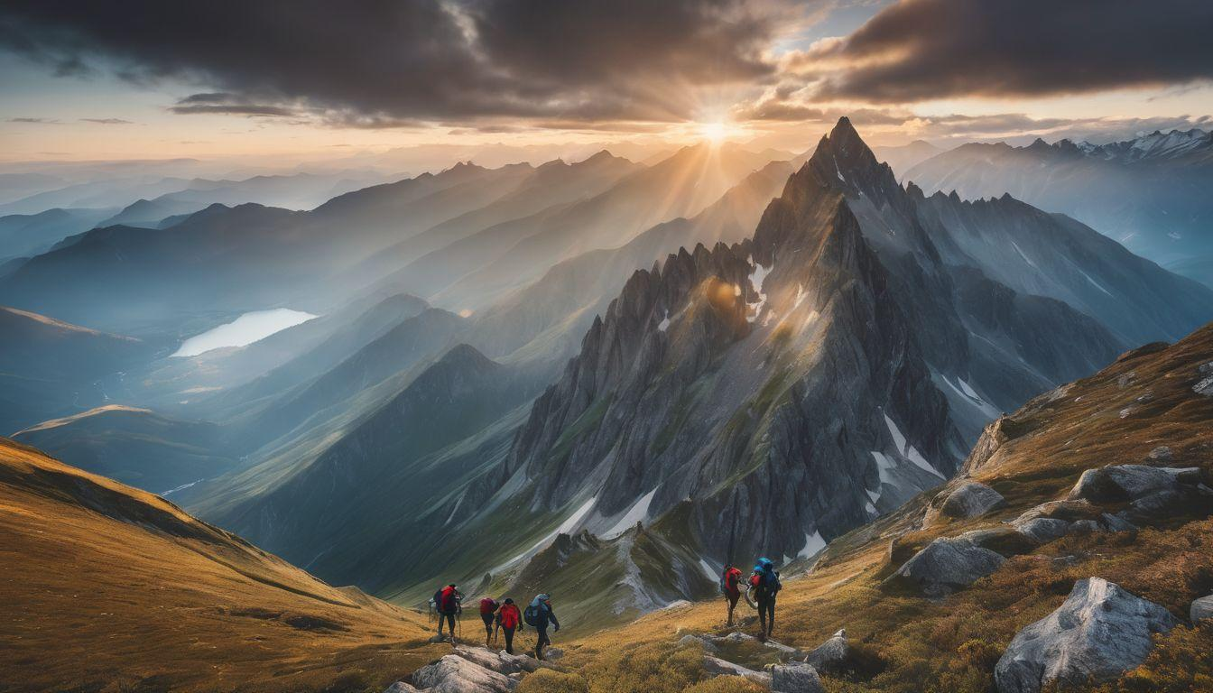
1. Navigation Bar
Contains the TrailQuest logo, links to Home, Trekking Routes, Camping, Schedule, Packages, and Contact, plus a Book Your Trip button.
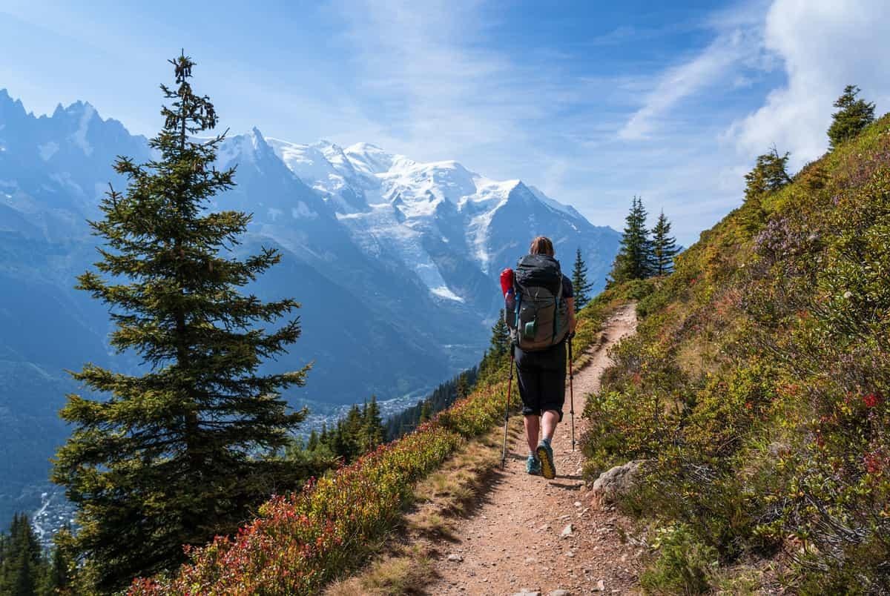
2. Trekking Routes
Displays four featured routes: Kodachadri Trek, Himalayan Base Camp, Kedarkantha Trek, and Stok Kangri Trek. Each card includes a location, distance, duration, price, and difficulty label.
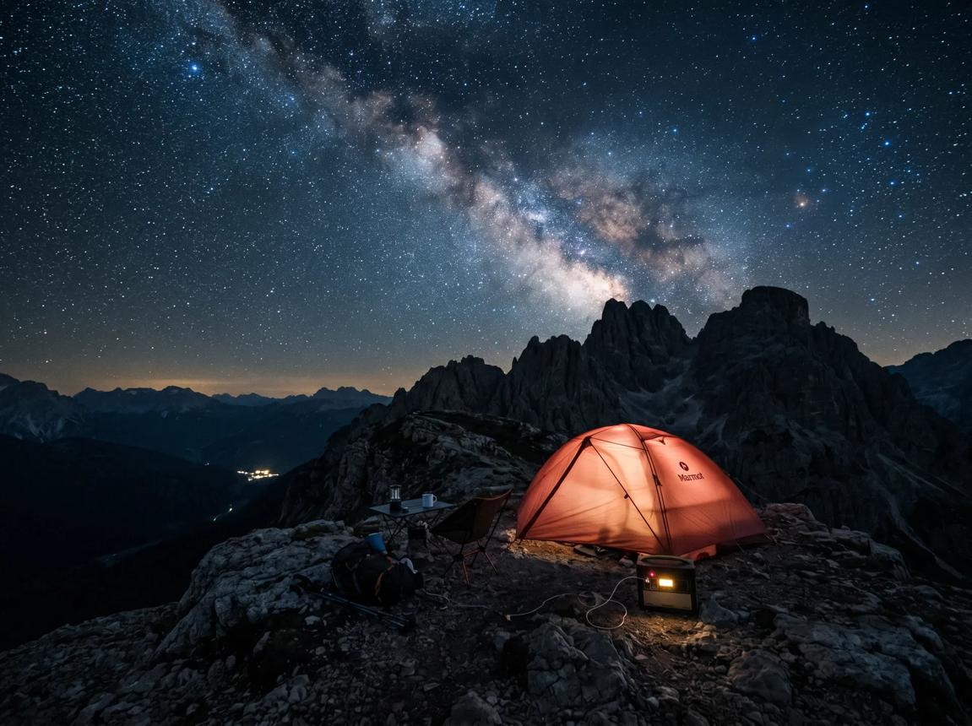
3. Camping and Difficulty Levels
Promotes camping trips and displays four difficulty categories: Easy, Moderate, Challenging, and Expert, helping visitors understand the intended experience level.
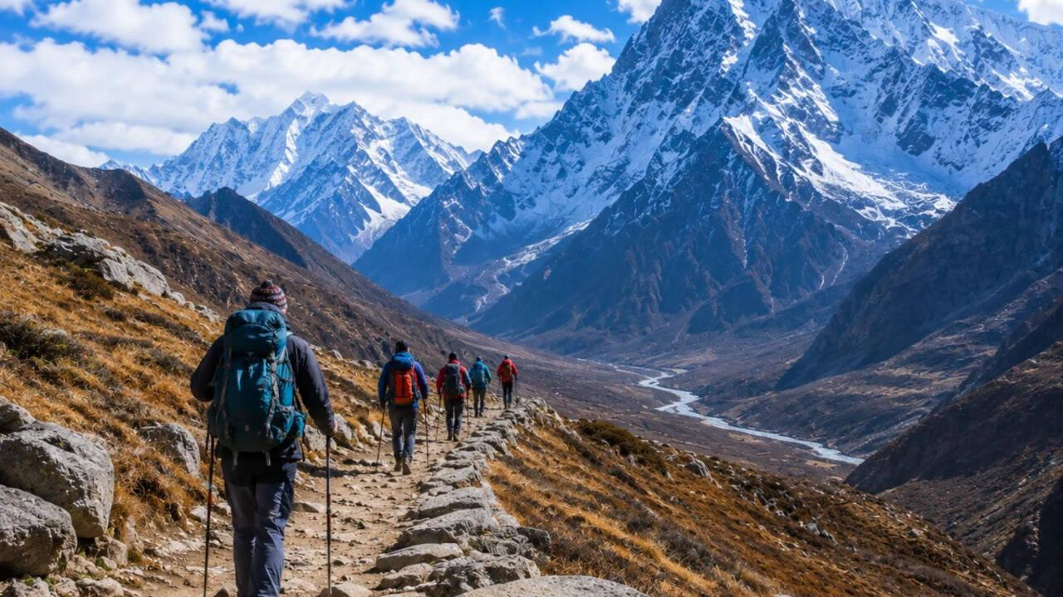
4. Trip Schedule
Presents a five-day itinerary covering arrival, acclimatization, trekking to base camp, mountain exploration, the main trek, and the return journey.
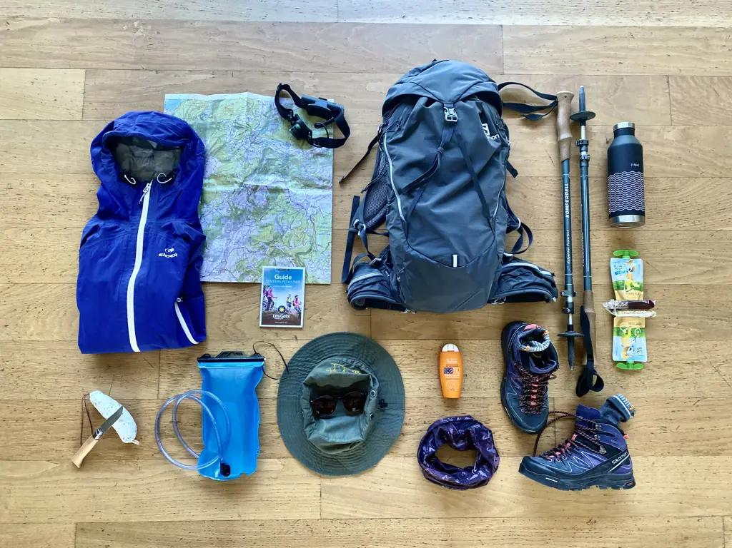
5. Equipment Checklist
Lists essential trekking items, including shoes, water bottles, backpacks, food, tents, sleeping bags, first-aid kits, warm clothing, and rain jackets.
6. Safety Guidelines
Provides reminders about following the guide, staying hydrated, checking weather conditions, avoiding solo trekking on unfamiliar routes, and respecting nature.
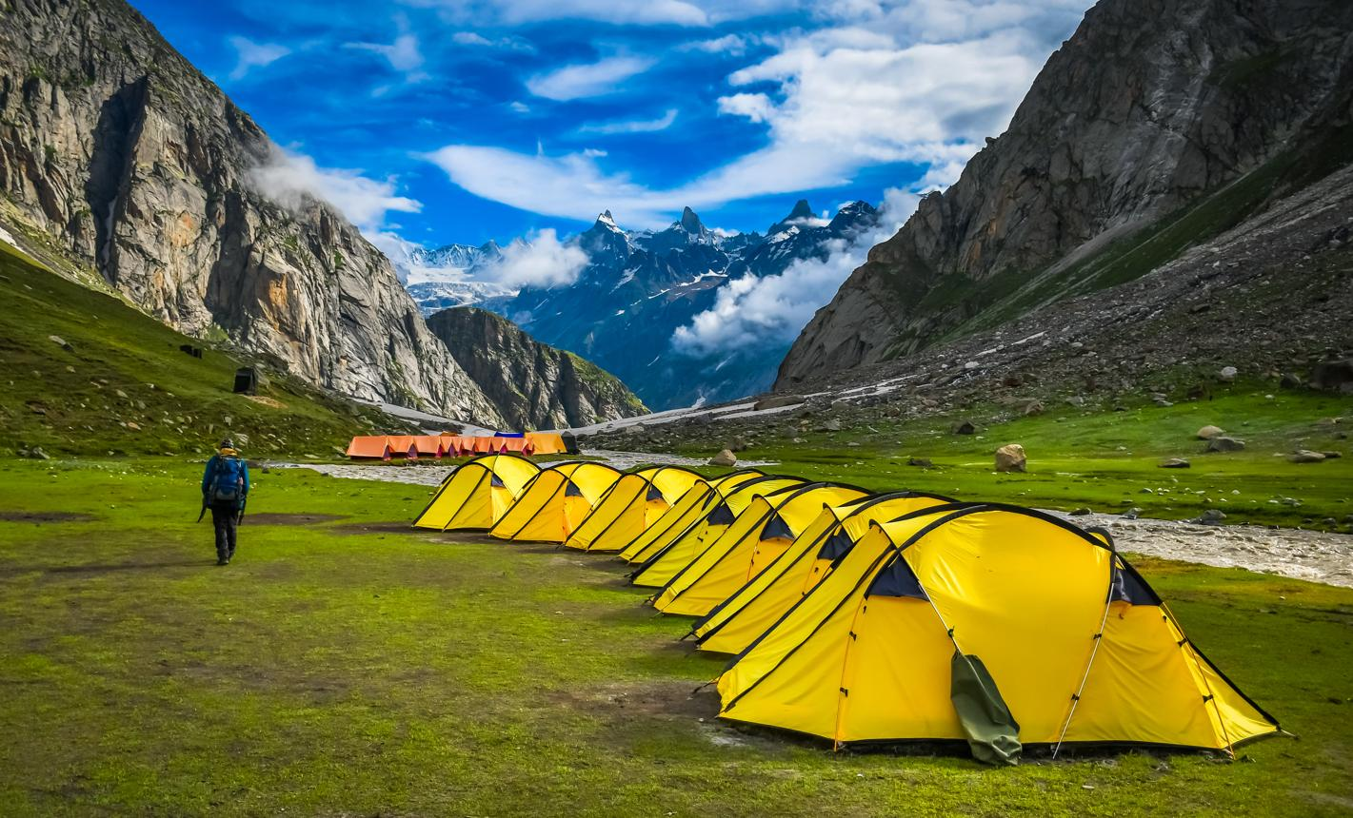
7. Packages and Pricing
Displays Basic, Standard, and Premium packages with different durations, prices, and included services. The Standard package is highlighted as popular.

8. Contact and Enquiry Form
Allows visitors to enter their name and email, choose a package, and submit an enquiry using the form.
Additional features include responsive layouts, green action buttons, image overlays, smooth scrolling, and a footer with the TrailQuest branding.

4. Development of the Website
The website can be developed using the following steps.
- Step 1: Requirement analysis
Identify the website's purpose and the information visitors need, including trekking routes, camping options, safety information, and prices.
- Step 2: HTML structure
Create the HTML document and divide it into the header, hero section, trekking routes, camping and difficulty section, trip schedule, equipment checklist, safety guidelines, packages, contact form, and footer.
- Step 3: CSS styling
Apply the dark blue and green color scheme, fonts, spacing, backgrounds, borders, and shadows.
- Step 4: Trekking card design
Create individual route cards with background images, difficulty badges, locations, distances, durations, and prices.
- Step 5: Camping and itinerary sections
Add the camping promotion, difficulty categories, and five-day schedule to help visitors plan their journeys.
- Step 6: Equipment and safety information
Display the equipment checklist and safety guidelines so visitors can review basic preparation requirements.
- Step 7: Package and enquiry sections
Create three package cards and a contact form with name, email, and package-selection fields.
- Step 8: Responsive design
Use CSS media queries at 1000px and 600px to adjust the number of columns and reorganize content on smaller screens.
- Step 9: Testing
Open the website in a browser and test navigation links, image loading, card layouts, package links, form validation, and mobile responsiveness.

5. Website Sections and Their Purpose
Section | Purpose
Home | Introduces TrailQuest and its adventure activities.
Trekking Routes | Displays trekking destinations, difficulty levels, distances, durations, and prices.
Camping | Promotes outdoor camping experiences.
Difficulty Levels | Helps visitors compare trekking experience levels.
Schedule | Shows the five-day trip itinerary.
Equipment Checklist | Lists essential trekking equipment.
Safety Guidelines | Provides basic trekking safety reminders.
Packages | Compares Basic, Standard, and Premium options.
Contact | Allows visitors to send enquiries.
Footer | Displays branding and copyright information.

6. Advantages of the Website
- Presents trekking information in one place.
- Helps visitors compare trekking routes and packages.
- Displays estimated trip durations and prices.
- Provides a useful equipment checklist.
- Highlights basic safety guidelines.
- Uses attractive mountain images and visual effects.
- Supports desktop, tablet, and mobile screen sizes.
- Demonstrates practical HTML and CSS web development concepts.

7. Limitations and Future Enhancements
The current website is a front-end demonstration. The enquiry form does not connect to a backend, database, or email service, so submitting the form does not create an actual booking.
Future enhancements could include:
- JavaScript: Add form validation and enquiry confirmation messages.
- Python with Flask or Django: Process enquiries and bookings on a server.
- Database integration: Store customer information and trip reservations.
- Online payments: Support secure payment for trekking packages.
- Live availability: Display available dates and remaining package slots.
- Weather information: Show current weather and forecasts for trekking destinations.
- Admin dashboard: Manage routes, prices, packages, and customer enquiries.
Maps and navigation: Display trekking locations and route maps.

8. Conclusion
The TrailQuest Adventure and Trekking website is a responsive website developed using HTML5 and CSS3. It provides trekking routes, camping information, difficulty levels, trip schedules, equipment checklists, safety guidelines, adventure packages, and an enquiry form.
The project demonstrates important web development concepts such as HTML structure, CSS Grid, Flexbox, background images, pseudo-elements, hover effects, forms, and responsive design. It is suitable for a beginner-level web development project and can be expanded into a complete adventure booking platform by adding JavaScript, a backend, and a database.

9.output
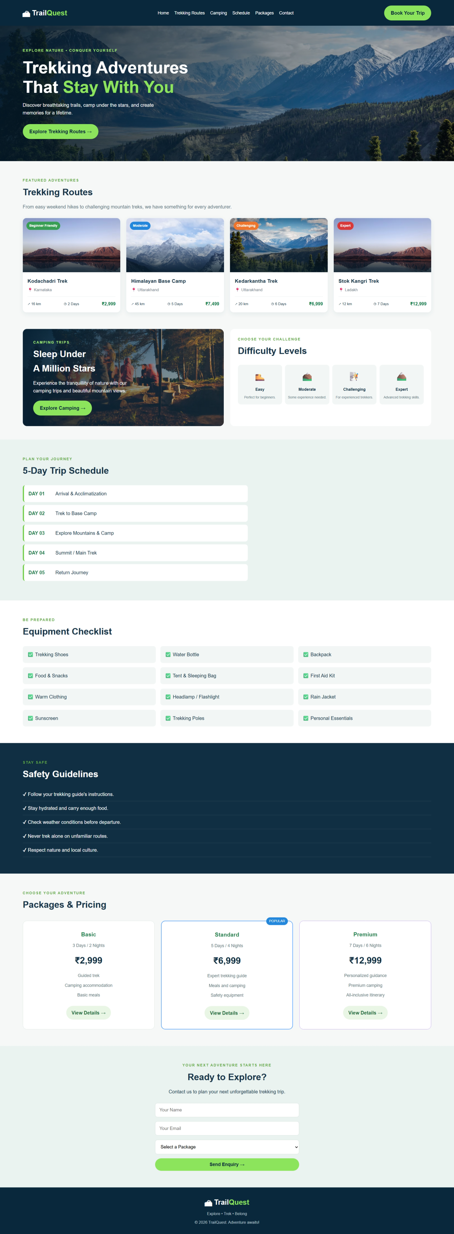

10.code
<!DOCTYPE html>
<html lang="en">
<head>
<meta charset="UTF-8">
<meta name="viewport" content="width=device-width, initial-scale=1.0">
<title>TrailQuest | Adventure & Trekking</title>

</head>
<style>

* {
margin: 0;
padding: 0;
box-sizing: border-box;
scroll-behavior: smooth;
}

body {
font-family: Arial, sans-serif;
background: #f5f8f7;
color: #173449;
line-height: 1.6;
}

header {
background: #09283c;
color: white;
padding: 18px 5%;
display: flex;
justify-content: space-between;
align-items: center;
flex-wrap: wrap;
gap: 15px;
}

.logo {
color: white;
font-size: 24px;
font-weight: bold;
text-decoration: none;
}

.logo span {
color: #8be45b;
}

nav {
display: flex;
flex-wrap: wrap;
gap: 18px;
}

nav a {
color: white;
text-decoration: none;
font-size: 14px;
}

nav a:hover {
color: #8be45b;
}

.book-btn, .btn {
display: inline-block;
background: #8be45b;
color: #09283c;
padding: 12px 22px;
border-radius: 30px;
font-weight: bold;
text-decoration: none;
border: none;
cursor: pointer;
}

.book-btn:hover, .btn:hover {
background: #6dce3e;
transform: translateY(-2px);
}

/* Hero */

.hero {
min-height: 450px;
display: flex;
align-items: center;
padding: 65px 5%;
color: white;
background:
linear-gradient(90deg, rgba(4, 25, 39, .9),
rgba(4, 25, 39, .2)),
url("https://images.unsplash.com/photo-1464822759023-fed622ff2c3b?auto=format&fit=crop&w=1800&q=85")
center/cover;
}

.hero-content {
max-width: 620px;
}

.tagline, .small-title {
color: #60a943;
font-weight: bold;
letter-spacing: 2px;
font-size: 12px;
}

.hero .tagline {
color: #a6f176;
}

.hero h1 {
font-size: clamp(34px, 5vw, 56px);
line-height: 1.15;
margin: 15px 0;
}

.hero h1 span {
color: #8be45b;
}

.hero-content > p:not(.tagline) {
margin-bottom: 25px;
max-width: 480px;
}

/* Common sections */

.section {
padding: 55px 5%;
}

.section h2, .features h2 {
font-size: 30px;
margin: 5px 0 12px;
}

.description {
margin-bottom: 25px;
color: #607582;
}

/* Trekking cards */

.route-container {
display: grid;
grid-template-columns: repeat(4, 1fr);
gap: 20px;
}

.route-card {
background: white;
border-radius: 12px;
overflow: hidden;
box-shadow: 0 5px 18px #18364a12;
transition: .3s;
}

.route-card:hover {
transform: translateY(-7px);
box-shadow: 0 12px 25px #18364a25;
}

.route-image {
height: 180px;
background-size: cover;
background-position: center;
position: relative;
}

.route-image::after {
content: "";
position: absolute;
inset: 45% 0 0;
background: linear-gradient(transparent, #071d2bd9);
}

.route1 {
background-image: url("https://images.unsplash.com/photo-1464278533981-50106e6176b1?auto=format&fit=crop&w=700&q=80");
}

.route2 {
background-image: url("https://images.unsplash.com/photo-1454496522488-7a8e488e8606?auto=format&fit=crop&w=700&q=80");
}

.route3 {
background-image: url("https://images.unsplash.com/photo-1464822759023-fed622ff2c3b?auto=format&fit=crop&w=700&q=80");
}

.route4 {
background-image: url("https://images.unsplash.com/photo-1464278533981-50106e6176b1?auto=format&fit=crop&w=700&q=80");
}

.level {
position: absolute;
top: 12px;
left: 12px;
z-index: 1;
padding: 5px 10px;
border-radius: 20px;
color: white;
font-size: 11px;
font-weight: bold;
}

.easy { background: #389e53; }
.moderate { background: #2387dc; }
.hard { background: #ee762c; }
.expert { background: #d93939; }

.route-info {
padding: 16px;
}

.route-info h3 {
font-size: 17px;
margin-bottom: 5px;
}

.route-info p {
color: #71818a;
font-size: 13px;
}

.route-details {
display: flex;
justify-content: space-between;
align-items: center;
flex-wrap: wrap;
gap: 8px;
border-top: 1px solid #e7edef;
margin-top: 12px;
padding-top: 12px;
font-size: 12px;
}

.route-details strong {
color: #14804a;
font-size: 15px;
}

/* Camping and difficulty */

.features {
padding: 0 5% 45px;
display: grid;
grid-template-columns: 1fr 1fr;
gap: 22px;
}

.camping-box {
padding: 35px;
min-height: 310px;
border-radius: 14px;
color: white;
background:
linear-gradient(90deg, #061e30e8, #061e3030),
url("https://images.unsplash.com/photo-1478131143081-80f7f84ca84d?auto=format&fit=crop&w=1000&q=80")
center/cover;
display: flex;
flex-direction: column;
align-items: flex-start;
justify-content: center;
}

.camping-box .small-title {
color: #a6f176;
}

.camping-box p:not(.small-title) {
margin-bottom: 20px;
max-width: 360px;
}

.difficulty-box {
background: white;
border-radius: 14px;
padding: 25px;
}

.difficulty-list {
display: grid;
grid-template-columns: repeat(4, 1fr);
gap: 10px;
margin-top: 22px;
}

.difficulty-list div {
background: #f2f7f5;
border-radius: 10px;
padding: 15px 8px;
text-align: center;
}

.difficulty-list span {
font-size: 30px;
}

.difficulty-list h3 {
font-size: 13px;
margin: 8px 0;
}

.difficulty-list p {
color: #627783;
font-size: 11px;
}

/* Schedule */

.schedule {
background: #eaf3ef;
}

.schedule-list {
max-width: 750px;
margin-top: 25px;
}

.schedule-list div {
display: flex;
gap: 25px;
padding: 15px;
margin-bottom: 10px;
background: white;
border-radius: 8px;
border-left: 4px solid #72cf48;
}

.schedule-list strong {
color: #24814d;
min-width: 65px;
}

/* Equipment */

.equipment {
background: white;
}

.equipment-list {
display: grid;
grid-template-columns: repeat(3, 1fr);
gap: 15px;
margin-top: 25px;
}

.equipment-list p {
padding: 15px;
border-radius: 8px;
background: #f2f7f5;
}

/* Safety */

.safety {
background: #102f43;
color: white;
}

.safety h2 {
color: white;
}

.safety ul {
list-style: none;
margin-top: 20px;
}

.safety li {
padding: 10px 0;
border-bottom: 1px solid #ffffff20;
}

/* Pricing */

.package-container {
display: grid;
grid-template-columns: repeat(3, 1fr);
gap: 22px;
margin-top: 30px;
}

.package-card {
background: white;
text-align: center;
padding: 30px 20px;
border: 1px solid #dbe6df;
border-radius: 14px;
position: relative;
transition: .3s;
}

.package-card:hover {
transform: translateY(-5px);
box-shadow: 0 12px 25px #18364a15;
}

.package-card h3 {
color: #23834c;
}

.package-card h2 {
color: #102f43;
margin: 15px 0;
}

.package-card p {
color: #687c85;
font-size: 14px;
margin: 10px 0;
}

.popular {
border: 2px solid #4b9bff;
}

.premium {
border-color: #b79af4;
}

.popular-label {
position: absolute;
top: -13px;
right: 15px;
background: #2387dc;
color: white;
padding: 4px 10px;
font-size: 11px;
border-radius: 15px;
}

.package-btn {
display: inline-block;
margin-top: 15px;
padding: 10px 18px;
border-radius: 25px;
background: #e9f6e5;
color: #246d3d;
text-decoration: none;
font-weight: bold;
}

/* Contact */

.contact {
background: #eaf3ef;
text-align: center;
}

.contact form {
max-width: 480px;
margin: 25px auto 0;
display: grid;
gap: 14px;
}

.contact input, .contact select {
width: 100%;
padding: 14px;
border: 1px solid #d3dfd9;
border-radius: 8px;
font-size: 15px;
background: white;
}

.contact .btn {
font-size: 15px;
}

/* Footer */

footer {
background: #09283c;
color: white;
text-align: center;
padding: 30px 15px;
}

footer p {
margin-top: 8px;
color: #bdccd5;
font-size: 13px;
}

/* Responsive design */

@media (max-width: 1000px) {
.route-container {
grid-template-columns: repeat(2, 1fr);
}

header {
justify-content: center;
}

.features {
grid-template-columns: 1fr;
}

.difficulty-list {
grid-template-columns: repeat(2, 1fr);
}
}

@media (max-width: 600px) {
header {
flex-direction: column;
}

nav {
justify-content: center;
gap: 12px;
}

.hero {
min-height: 400px;
padding: 45px 6%;
}

.hero h1 {
font-size: 36px;
}

.route-container,
.package-container,
.equipment-list {
grid-template-columns: 1fr;
}

.section {
padding: 40px 5%;
}

.features {
padding: 0 5% 35px;
}

.camping-box {
padding: 25px;
}

.schedule-list div {
gap: 12px;
font-size: 13px;
}
}

</style>
<body>

<!-- Navigation -->
<header>
<a href="#home" class="logo">🏔 Trail<span>Quest</span></a>

<nav>
<a href="#home">Home</a>
<a href="#routes">Trekking Routes</a>
<a href="#camping">Camping</a>
<a href="#schedule">Schedule</a>
<a href="#packages">Packages</a>
<a href="#contact">Contact</a>
</nav>

<a href="#packages" class="book-btn">Book Your Trip</a>
</header>

<!-- Hero Section -->
<section class="hero" id="home">
<div class="hero-content">
<p class="tagline">EXPLORE NATURE • CONQUER YOURSELF</p>
<h1>Trekking Adventures<br>
That <span>Stay With You</span>
</h1>
<p>
Discover breathtaking trails, camp under the stars,
and create memories for a lifetime.
</p>
<a href="#routes" class="btn">Explore Trekking Routes →</a>
</div>
</section>

<!-- Trekking Routes -->
<section class="section" id="routes">
<p class="small-title">FEATURED ADVENTURES</p>
<h2>Trekking Routes</h2>
<p class="description">
From easy weekend hikes to challenging mountain treks,
we have something for every adventurer.
</p>

<div class="route-container">

<div class="route-card">
<div class="route-image route1">
<span class="level easy">Beginner Friendly</span>
</div>
<div class="route-info">
<h3>Kodachadri Trek</h3>
<p>📍 Karnataka</p>
<div class="route-details">
<span>↗ 16 km</span>
<span>◷ 2 Days</span>
<strong>₹2,999</strong>
</div>
</div>
</div>

<div class="route-card">
<div class="route-image route2">
<span class="level moderate">Moderate</span>
</div>
<div class="route-info">
<h3>Himalayan Base Camp</h3>
<p>📍 Uttarakhand</p>
<div class="route-details">
<span>↗ 45 km</span>
<span>◷ 5 Days</span>
<strong>₹7,499</strong>
</div>
</div>
</div>

<div class="route-card">
<div class="route-image route3">
<span class="level hard">Challenging</span>
</div>
<div class="route-info">
<h3>Kedarkantha Trek</h3>
<p>📍 Uttarakhand</p>
<div class="route-details">
<span>↗ 20 km</span>
<span>◷ 6 Days</span>
<strong>₹6,999</strong>
</div>
</div>
</div>

<div class="route-card">
<div class="route-image route4">
<span class="level expert">Expert</span>
</div>
<div class="route-info">
<h3>Stok Kangri Trek</h3>
<p>📍 Ladakh</p>
<div class="route-details">
<span>↗ 12 km</span>
<span>◷ 7 Days</span>
<strong>₹12,999</strong>
</div>
</div>
</div>

</div>
</section>

<!-- Camping and Difficulty -->
<section class="features" id="camping">

<div class="camping-box">
<p class="small-title">CAMPING TRIPS</p>
<h2>Sleep Under<br>A Million Stars</h2>
<p>
Experience the tranquillity of nature with our
camping trips and beautiful mountain views.
</p>
<a href="#packages" class="btn">Explore Camping →</a>
</div>

<div class="difficulty-box">
<p class="small-title">CHOOSE YOUR CHALLENGE</p>
<h2>Difficulty Levels</h2>

<div class="difficulty-list">
<div>
<span>🥾</span>
<h3>Easy</h3>
<p>Perfect for beginners.</p>
</div>
<div>
<span>⛰️</span>
<h3>Moderate</h3>
<p>Some experience needed.</p>
</div>
<div>
<span>🧗</span>
<h3>Challenging</h3>
<p>For experienced trekkers.</p>
</div>
<div>
<span>🏔️</span>
<h3>Expert</h3>
<p>Advanced trekking skills.</p>
</div>
</div>
</div>
</section>

<!-- Trip Schedule -->
<section class="schedule section" id="schedule">
<p class="small-title">PLAN YOUR JOURNEY</p>
<h2>5-Day Trip Schedule</h2>

<div class="schedule-list">
<div><strong>DAY 01</strong><span>Arrival & Acclimatization</span></div>
<div><strong>DAY 02</strong><span>Trek to Base Camp</span></div>
<div><strong>DAY 03</strong><span>Explore Mountains & Camp</span></div>
<div><strong>DAY 04</strong><span>Summit / Main Trek</span></div>
<div><strong>DAY 05</strong><span>Return Journey</span></div>
</div>
</section>

<!-- Equipment Checklist -->
<section class="equipment section">
<p class="small-title">BE PREPARED</p>
<h2>Equipment Checklist</h2>

<div class="equipment-list">
<p>✅ Trekking Shoes</p>
<p>✅ Water Bottle</p>
<p>✅ Backpack</p>
<p>✅ Food & Snacks</p>
<p>✅ Tent & Sleeping Bag</p>
<p>✅ First Aid Kit</p>
<p>✅ Warm Clothing</p>
<p>✅ Headlamp / Flashlight</p>
<p>✅ Rain Jacket</p>
<p>✅ Sunscreen</p>
<p>✅ Trekking Poles</p>
<p>✅ Personal Essentials</p>
</div>
</section>

<!-- Safety Guidelines -->
<section class="safety section">
<p class="small-title">STAY SAFE</p>
<h2>Safety Guidelines</h2>

<ul>
<li>✔ Follow your trekking guide's instructions.</li>
<li>✔ Stay hydrated and carry enough food.</li>
<li>✔ Check weather conditions before departure.</li>
<li>✔ Never trek alone on unfamiliar routes.</li>
<li>✔ Respect nature and local culture.</li>
</ul>
</section>

<!-- Packages -->
<section class="section" id="packages">
<p class="small-title">CHOOSE YOUR ADVENTURE</p>
<h2>Packages & Pricing</h2>

<div class="package-container">

<div class="package-card">
<h3>Basic</h3>
<p>3 Days / 2 Nights</p>
<h2>₹2,999</h2>
<p>Guided trek</p>
<p>Camping accommodation</p>
<p>Basic meals</p>
<a href="#contact" class="package-btn">View Details →</a>
</div>

<div class="package-card popular">
<span class="popular-label">POPULAR</span>
<h3>Standard</h3>
<p>5 Days / 4 Nights</p>
<h2>₹6,999</h2>
<p>Expert trekking guide</p>
<p>Meals and camping</p>
<p>Safety equipment</p>
<a href="#contact" class="package-btn">View Details →</a>
</div>

<div class="package-card premium">
<h3>Premium</h3>
<p>7 Days / 6 Nights</p>
<h2>₹12,999</h2>
<p>Personalized guidance</p>
<p>Premium camping</p>
<p>All-inclusive itinerary</p>
<a href="#contact" class="package-btn">View Details →</a>
</div>

</div>
</section>

<!-- Contact -->
<section class="contact section" id="contact">
<p class="small-title">YOUR NEXT ADVENTURE STARTS HERE</p>
<h2>Ready to Explore?</h2>
<p>Contact us to plan your next unforgettable trekking trip.</p>

<form>
<input type="text" placeholder="Your Name" required>
<input type="email" placeholder="Your Email" required>

<select required>
<option value="">Select a Package</option>
<option>Basic - ₹2,999</option>
<option>Standard - ₹6,999</option>
<option>Premium - ₹12,999</option>
</select>

<button type="submit" class="btn">Send Enquiry →</button>
</form>
</section>

<!-- Footer -->
<footer>
<a href="#home" class="logo">🏔 Trail<span>Quest</span></a>
<p>Explore • Trek • Belong</p>
<p>© 2026 TrailQuest. Adventure awaits!</p>
</footer>

</body>
</html>

